Loknete Hon. Hanmantrao Patil Charitable Trust’s,
Adarsh Institute of Technology & Research Centre, Vita
DEPARTMENT OF COMPUTER SCIENCE & ENGINEERING

A
SEMINAR REPORT
ON
“Digital Mobile Marketing”
Academic year
2021-22
Submitted By
Student Name Roll No
Aishwarya Mahadev Gaikwad CS2022

Under the Guidance of
Asst. Prof. Lad S. S.

Loknete Hon. Hanmantrao Patil Charitable Trust’s,
Adarsh Institute of Technology & Research Centre, Vita
DEPARTMENT OF COMPUTER SCIENCE & ENGINEERING
CERTIFICATE
This is to certify that, Ms. Gaikwad Aishwarya Mahadev is studying in SY B.Tech Computer Science & Engineering course in SEM III & IV and she has successfully completed the Design report, entitled “Digital Mobile Marketing”, in partial fulfillment of the award of Bachelor of Computer Science & Engineering as laid down by the Dbatu University, Lonere during academic year 2021-2022.

Guide H.O. D
Prof. Lad S.S.

External Examiner Principal
Place: Vita Prof. Dr. Mahadik D.K.
Date:
Acknowledgement

It gives us great pleasure to remain deeply indebted to our estimated guide Prof. Lad S. S. under whom we have worked. We wish to express our deep sense of gratitude to our guide for his continuous encouragement, keen interest and able guidance during the entire period of the project work. He highlighted the key areas in this topic that helped get right content in the topic.
Secondly, I would like to express my gratitude for the constant inspiration given by our academic coordinator Prof. Ingale V.B.
Also, I would like to thanks to our Principal Prof. Dr. Mahadik D. K. for providing required facility and infrastructure during entire semester.
I would like to express my gratitude to all my colleagues for their support, co-operation and fruitful discussions on diverse seminar topics and technical help.
I would especially like to thank my family and friends for their sincere interest in my study and theirs moral support.

Gaikwad Aishwarya M. [2022]

CHAPTER NO. | TITLE | PAGE NO.
1 | ABSTRACT
2 | INTRODUCTION
3 | PROBLEM DEFINITION
4 | REQUIREMENTS ANALYSIS  2.1 H/W REQUIREMENT  2.2 S/W REQUIREMENT
5 | DESIGN METHODOLOGY  4.1 SYSTEM ARCHITECTURE  4.2 DATA FLOW DIAGRAM  4.3 FLOW CHART
6 | IMPLEMENTATION DETAILS  5.1 TECHNOLOGY  5.2 MODULES  (module wise info and snapshots)
7 | CONCLUSION
8 | REFERENCE
INDEX

ABSTRCT:-
Component of mobile commerce use of wireless hand held devices to buy and sell goods and services.Interaction with customers through wireless telecommunication. Cell phones provide direct contact to customers (one –to-one marketing).

INTRODUCTION: -
Mobile technology is steadily becoming simper meaning that more people are finding it easy and comfortable to use of smart phones.The result consumers are becoming more open to mobile commerce and more willing to act an offers from mobile ads.

SYSTEM OBJECTIVE: -
1.Increase sales/profits: -

One of the major objectives of digital marketing is to increase the number of sales of your products and services.ultimately it will increase the wealth of your business and your profit.it involves selling the right products and services to the right customers.

2. Brand Awareness: -
Brand awareness is one of the important aspects and objective of digital marketing. it will increase your business reach and a large number of people will get to know about your business name and profile.
3.Target customers: -
Change is one of the phenomena of the nature if you do not expand your business somebody else will take aware your customers.

SCOPE: -
Mobile marketing has a great scope as people spend maximum time on their mobile devices and hence to reach customers has become easy.
big brands have got their location based mobile apps developed in order to serve customers better.

REQUIREMENT ANALYSIS:-
- HARDWARE REQUIREMENT:
RAM - 1GB
Processor - 3.00Megahertz Intel Platinum IV
Space - 5GB HDD(Max)
Operating System - Windows 7 and Above
Hard Disk - 40 GB (Min)
Keyboard - Standard Windows Keyboard

- SOFTWARE REQUIREMENT:
Operating System - Windows95/98/2000/XP, Windows 7
Front End language - HTML, CSS, JavaScript
Front-End Tool - Visual Studio Code

DESIGN METHODOLOGY: -
1.SYSTEM ARCHITECTURE: -

Mobile marketing app

video
E-Mail

Social media
SMS
Games
Display

Data Flow Diagrams: -
market
- Actions
Search
Discussion
Promotion
Purchase
Sharing
- Flows
Ownership
Possession
Money

ppp

- Feed
1.Supply and demand
2.Hard and software
3.Digital infrastructure
4.ICT
- Outcome
1.variety of services
2.Value
3.Economical growth
4.Social development
feed

IMPLEMENTATION DETAILS: -
TECNOLOGY: -
HTML: -HTML is at the core of every web page, regardless the complexity of a site or number of technologies involved. It's an essential skill for any web professional. It's the starting point for anyone learning how to create content for the web. And, luckily for us, it's surprisingly easy to learn.
CSS: -CSS stands for Cascading Style Sheets. This programming language dictates how the HTML elements of a website should actually appear on the front end of the page.
JavaScript: - JavaScript is a logic-based programming language that can be used to modify website content and make it behave in different ways in response to a user's actions. Common uses for JavaScript include confirmation boxes, calls-to-action, and adding new identities to existing information.

MODULES: -
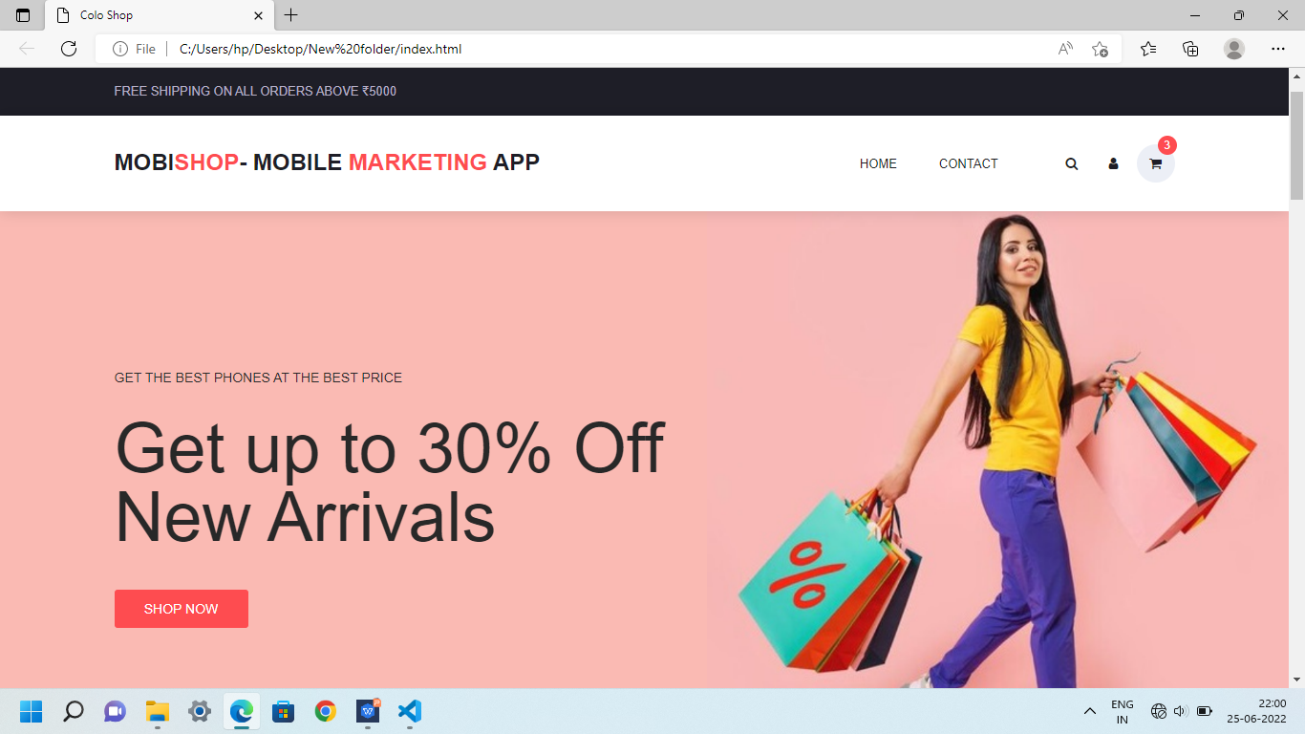

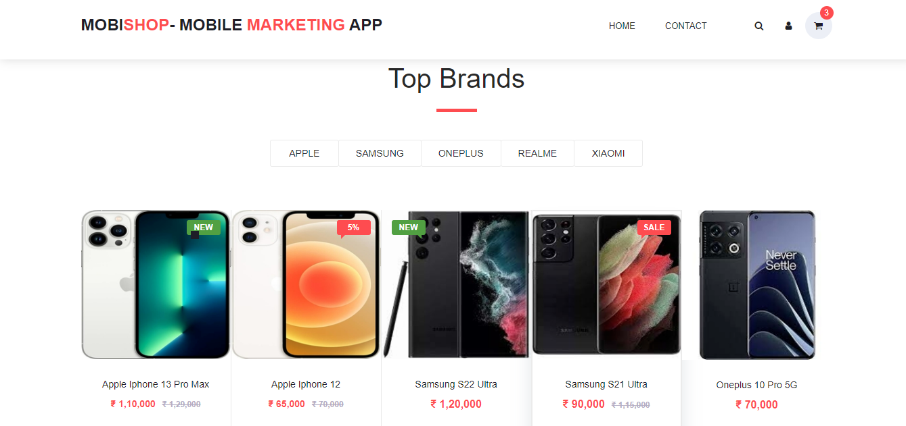

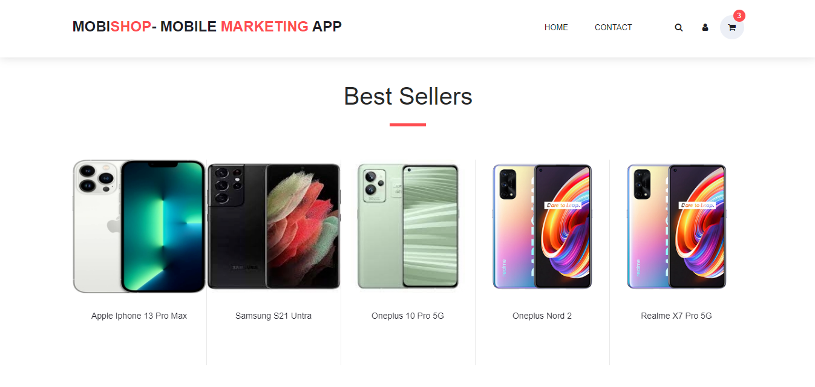

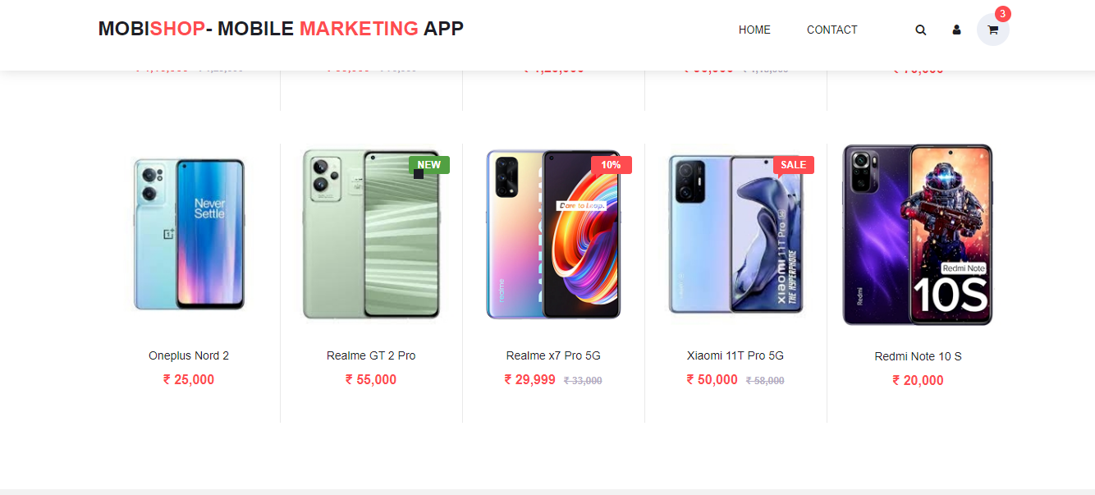

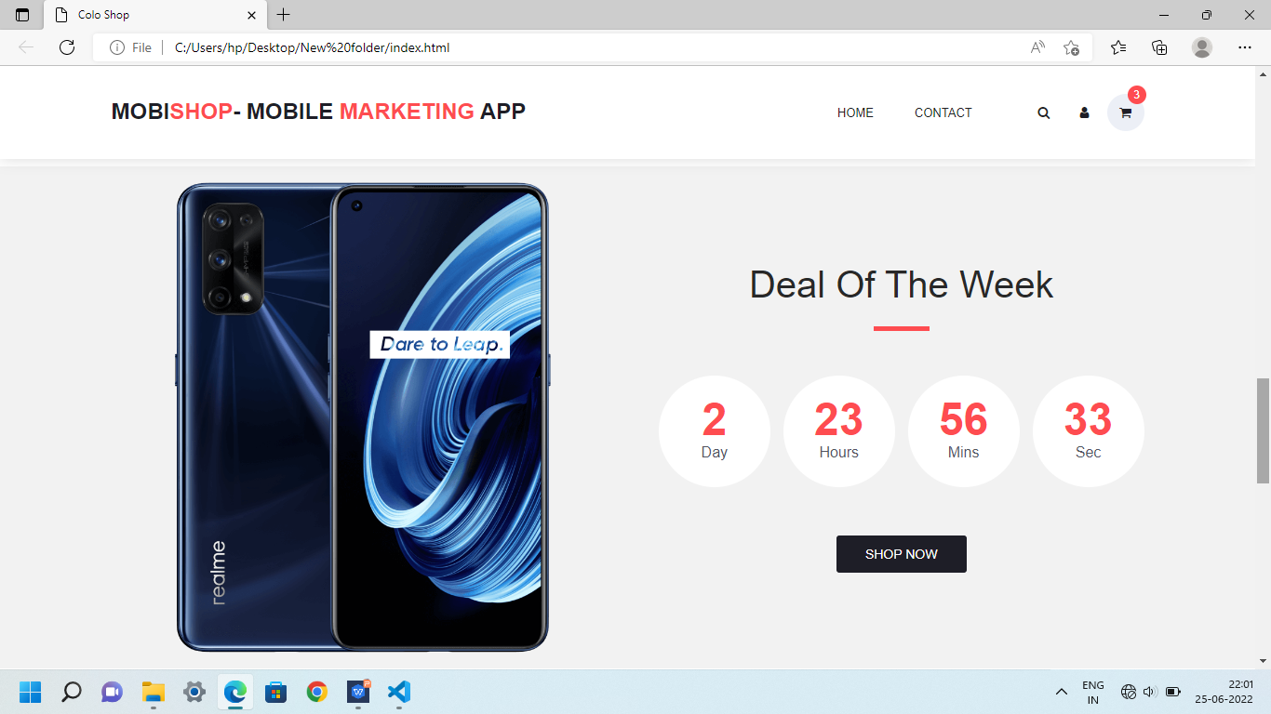

CONCLUSION: -
So by now user should already know the potential of using mobile marketing to enhance other marketing strategies ,boost brand awareness,increase sales and rich more prospects.
cell phones have brought on a whole new age of technology and they do make life more convenient in terms of communication.

REFERENCE: -
1.www.google.com.
2. w3schools.com
3. The Complete Reference, HTML & CSS, Thomas A. Powell

